Section 1: The Opportunity
Opportunity: Meeting prep is inefficient and scattered, so teams arrive unaligned and waste the first 5–10 minutes “warming up” instead of deciding. Calendars are full, but the context lives across emails, slides, docs, and chat threads. Even when there’s an agenda, it rarely highlights the decision to be made, the options, and the risks/trade-offs. People skim the wrong versions, key links are missing, and action items drift into more meetings. Hybrid work amplifies this: information multiplies across tools while attention does not.
Who’s trying to get what done?
Managers, PMs, and cross-functional teams want to walk into a meeting already aligned on goal, context, decision(s), and next steps—so they can make a clear call and leave with owners and dates.
What makes that job difficult, frustrating, or costly?
- Prep takes time: finding the latest doc, deduping threads, and summarizing context.
- Agendas lack decision framing; “discussion” replaces “decision.”
- Version chaos: wrong files, missing links, stale data.
- Hybrid reality: context is fragmented across email, Drive, Slack/Teams, and tickets.
- The cost shows up as slow decisions, repeat meetings, and unclear ownership.
What would make it easier, more reliable, or more meaningful?
- A single, concise brief for each meeting: Goal → Context → Risks/Trade-offs → Decision(s) → Action Checklist (owner + date).
- Automatic retrieval of only the relevant passages from linked materials.
- Version-aware links and lightweight verification that attendees have reviewed the brief.
- Clear decision framing and default decision deadlines to reduce drift.
Jobs-to-be-Done prompts I used (for validation with users):
- What are you trying to get done in your day-to-day work before a meeting starts?
- Where does prep feel inefficient or overly complicated?
- Which tools or steps are you re-doing because information is scattered?
- If you had a one-pager before every meeting, what must it include to be useful?
- What tools do you wish existed, or what would make this easier?
Comparative Analysis (current vs. AI-enabled):
- Today (non-AI): Manual prep across email/Drive/Slack; copy-paste summaries; agenda templates without decision framing; human effort to find latest versions; high variance in quality; frequent follow-up meetings.
- With AI-enabled workflow: Auto-assemble a decision-ready brief from invite metadata and linked docs; retrieve and summarize only relevant passages; highlight decisions, options, and risks; verify links and versions; generate an action checklist with owners/dates—making prep faster, more consistent, and reliably “decision-first.”

Section 2: The AI-Enabled Solution

What I will build (what it is, what it does)
A lightweight web app that listens to calendar events and auto-creates a concise, decision-ready brief for each meeting. When an event is created or updated, the app gathers the invite metadata and any linked materials, reads only the relevant parts, and produces a one-pager with:
- Goal
- Context
- Risks / Trade-offs
- Decision(s) to Make
- Action Checklist (owner + due date)
The brief is inserted back into the calendar invite (or shared as a doc), so everyone sees the same summary before the meeting.

What AI tools I will use and why
- ChatGPT / GPT-4.1 (or similar LLM): for summarizing sources, extracting decisions/options/risks, and drafting the one-pager in a consistent format.
- Embeddings + Vector DB (e.g., OpenAI Embeddings + FAISS/Pinecone): to power Retrieval-Augmented Generation (RAG) so only relevant passages are fed to the model.
- Calendar & Docs APIs (Google/Microsoft): to read event metadata, fetch linked files, and write the brief back to the invite.

How the end-user experiences AI
- Before the meeting: The invite updates with a one-pager. Attendees see the decision, options, risks, and links to the latest sources.
- In the meeting: The brief keeps the group on the decision path; action items are captured with owner + date.
- After the meeting: Action items can auto-become tickets; owners get gentle nudges; leaders can review simple analytics on decision quality and repeat meetings.

How it works (inputs, prompts, structure, workflow)
Inputs
- Calendar event metadata (title, attendees, time, description).
- Linked materials (docs, slides, sheets, tickets, threads).
- Optional labels (meeting type, audience: Exec vs IC).
Workflow
- Trigger: Calendar webhook fires on create/update.
- Resolve sources: Follow links in the invite; fetch the latest versions.
- Chunk & index: Split docs, slides, and threads; embed chunks into a vector index.
- RAG query: Build a focused query from the event title/description; retrieve top-k chunks (e.g., k=12).
- Structured prompt to LLM:
  - Extract Goal, Context, Options, Risks/Trade-offs, Decision(s), Action Checklist.
  - Enforce a one-page limit and bullet-first style; include canonical links.
  - If audience label is Exec, compress context and emphasize options/risks; if IC, add more implementation detail.
- Post back: Write the brief to the invite and (optionally) export to a doc; create tickets from Action Checklist lines with “owner • task • due date.”
- Nudges & analytics: Send reminders; log decision timestamps and follow-up rates.
Structure
- Strict JSON schema for model output → deterministic mapping into the one-pager.
- Version checks to avoid stale links.
- Guardrails: max token budget, citation list of source URLs, toxicity/PII filters for shared briefs.

Why this is better than current options
- Manual prep is slow and inconsistent; generic note bots are noisy and unfocused.
- This app automates the specific job-to-be-done: a decision-ready brief with correct links, clear options, explicit risks, and owners/dates—reducing pre-meeting anxiety, repeat meetings, and misalignment.

Evidence (What I have built)
- To test my idea I created a GPT that functions like the web app I have proposed
- The final version of this project will be a web app, but a GPT gives me a quicker MVP
- This version is upload only, but the final web app will use webhooks
- https://chatgpt.com/g/g-6913b84c147c819190098a4db18374a0-briefbot
- 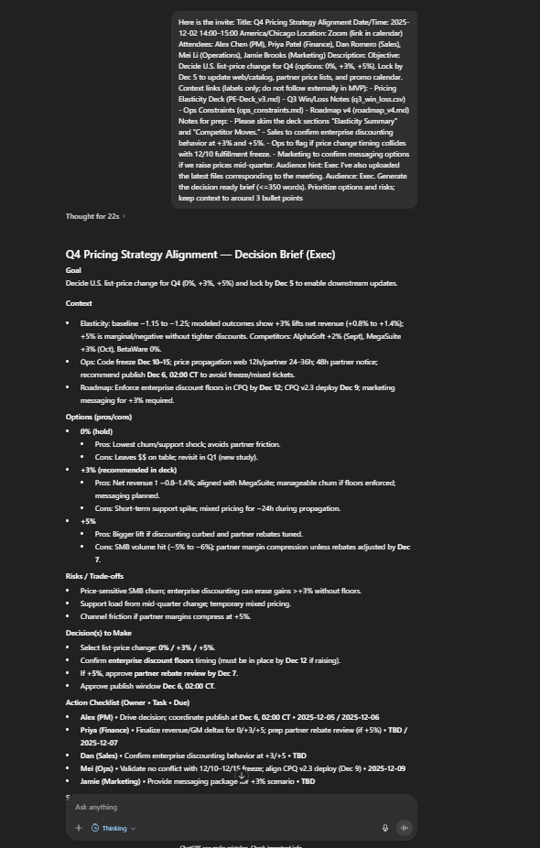

Appendix: 3 prompts I tested
- Decision-First (Exec audience)
  - Prompt: “Here’s the invite (pasted) and I’ve uploaded the latest files. Audience: Exec. Generate the decision-ready brief (≤350 words). Prioritize options and risks; keep context to ≤3 bullets.”
  - Notes: I instructed the GPT to enforce a JSON format for later in the project when I would need to export the output, but I wasn’t clear enough in the instructions so it outputted the JSON. But a simple adjustment to the system prompt was enough to fix that. Otherwise, the output is exactly what I expected: Tight one-pager, exec-level; strong Options/Risks, minimal context, clear Decision(s) and Action Checklist using real owners only.
- Execution-Ready (IC audience)
  - Prompt: “Using the uploaded invite + docs, audience: IC. Generate the brief and expand implementation constraints in Context. In Actions, use the format: Owner • Task • Due. If owner/date missing, use TBD (role) and TBD (date).”
  - Notes: More detail for implementers; concrete tasks, dependencies, and constraints pulled from the files.
- Gap-Filler (insufficient inputs)
  - Prompt: “Before generating the brief, ask me only 2–3 targeted questions if critical details are missing (e.g., exact decision, owners, or latest doc). After I answer, produce the brief.”
  - Notes: Minimal, focused clarification followed by a complete brief; avoids long back-and-forth.

Section 3: Value Explanation

Who benefits
- Decision owners (Execs, PMs, leads): Walk into meetings with a clear decision frame, not a pile of links.
- Cross-functional attendees (Sales, Finance, Ops, Marketing, Eng): See the same up-to-date context, options, and risks.
- Coordinators (chiefs of staff, program managers): Replace manual pre-reads and version-chasing with a consistent one-pager.
- Distributed/hybrid teams: Reduce cold starts and misalignment across time zones and tools.

What kind of value is created
- Functional: A concise, decision-ready brief with correct links, explicit options/pros/cons, risks, and an action checklist (owner • task • due).
- Emotional: Lower pre-meeting anxiety; people feel prepared and less blindsided.
- Economic: Fewer “meeting to prep the meeting” cycles; faster time-to-decision; less rework from stale docs.
- Social: Shared ritual and vocabulary (“Goal → Context → Options → Risks → Decision → Actions”) that improves team norms.
- Creative: Frees attention for strategy and problem-solving instead of scavenging info.

The job-to-be-done it completes
“When I’m convening or joining a meeting, help me arrive aligned on the decision, the viable options, the trade-offs, and who must do what by when—so we can make the call in one sitting and move.”
Concretely, it:
- Converts scattered materials into a single, trustworthy pre-read.
- Surfaces the decision(s) to make and options with pros/cons grounded in the docs.
- Captures an action checklist with owners and dates to ensure execution.

Why this matters now
- Hybrid is the norm; attention is not. Context is spread across email, chat, slides, tickets; meetings start cold.
- Meeting inflation + budget discipline. Organizations need the same (or better) outcomes with fewer cycles.
- AI maturity for retrieval. RAG makes it feasible to extract only the relevant passages from user-provided files—precisely what generic note bots miss.

If expanded or improved, focus here
- Role-specific briefs: Exec vs. IC variants (already supported conceptually) with tighter knobs for depth, risk emphasis, and recommendation strength.
- Lightweight integrations (optional): One-click ticket creation from action items; nudges to owners before recurring meetings; export to docs or wikis.
- Decision health analytics: Track time-to-decision, reopen rates, and common blockers; surface “chronic time sinks” to leaders.
- Version assurance: Automatic “latest file” checks and stale-flagging across multiple versions.
- Governance & scale: Templates by meeting type (go/no-go, incident, roadmap), audit trail of sources, privacy controls, and multilingual briefs for global teams.
Bottom line: The solution replaces noisy notes and manual prep with a consistent, decision-first pre-read—improving speed, clarity, and follow-through right where modern teams feel the most friction.

Section 4: Reflections on AI Use
AI allows for ideas to be iterated on very quickly. Building with AI takes far less time than building without it. It gives the opportunity for non-technical people to create software, while boosting the productivity of those who already knew how to make it. I was surprised how easy it was to set up a GPT. It also helped me format my ideas in this document, saving me time on rephrasing and formatting. A simple system prompt creates very consistent outputs for what I viewed as an entirely non-deterministic technology. The limitations largely came down to context. Without an abundance of context, the AI did not behave properly at all. I had to spend a lot of time crafting the system prompt for the GPT because it would produce behaviors that I didn’t want. With a lot of context, I think AI has few limitations (given the task you are performing is conducive to the technology).

Section 5: Ethics & Responsibility
Privacy & Permissions
- Data scope: Process only the invite text and files users upload; do not fetch external links in the MVP.
- Consent & least privilege: Require explicit user action to include a file in a brief; no background ingestion.
- Storage/retention: Default to ephemeral processing—don’t store content after the brief is generated. If users opt to save, show retention period and allow Export/Delete at any time.
- Security: Encrypt at rest/in transit; restrict internal access; maintain audit logs showing who generated/Viewed which brief.
- Sensitive content handling: Redact PII/financial/customer identifiers by rule (regex + heuristic pass) before summarization; flag if redaction might hide decision-critical details.
Labor Impacts
- Transformation, not blind automation: The tool shifts work from manual prep to decision framing. Keep human-in-the-loop: owners confirm the brief and action items before sharing.
- Role transparency: Clarify new responsibilities (e.g., coordinator validates sources; decision owner approves options/risks).
- Upskilling: Provide short guides for “good inputs” and “decision framing” to raise overall quality instead of displacing coordinators.
- Risk of de-skilling: Mitigate by rotating brief reviewers and preserving links to originals so teams stay close to source material.
Accessibility & Inclusion
- Readable by default: ≤350 words, clear headings, bullet-first; compatible with screen readers (ordered headings, alt text for any images in future versions).
- Standards: Target WCAG 2.2 AA for color contrast, keyboard navigation, focus states.
- Language & localization: Simple English by default; support translation and glossaries for jargon-heavy contexts.
- Neurodiversity: Offer “Exec” (compressed) and “IC” (expanded) modes; allow larger text and line spacing.
Bias & Fairness
- Source-bound summaries: Constrain outputs to uploaded passages; cite filenames/sections to reduce hallucinations and subjective spin.
- Option framing checks: Require at least two viable options; prompt for counter-arguments to avoid single-path bias.
- Risk of stereotyping owners/roles: Never infer owners from names; use provided roles only. If unknown, mark TBD (role).
- Evaluation & feedback: Add a lightweight review step (“Was any claim unsupported or slanted?”). Log and retrain prompts on flagged cases; maintain a bias test set (e.g., varied segments/customers/regions).

Governance (what “good” looks like)
- Publish a short Model & Data Use Notice in the app.
- Provide a Data Rights panel (export/delete/history).
- Document limits (no external browsing in MVP; accuracy depends on uploaded materials).
- Establish escalation paths: privacy contact, incident response, and quarterly reviews of retention, access logs, and bias metrics.
Bottom line: Keep the system narrow, transparent, and reviewable. Make humans the decision-makers; the tool should compress evidence, not override judgment.

Section 6: Usability Testing
I showed my solution to my mother (an upper manager at BMO) and this is what she said:
- She said it was a great idea, but it would be difficult to achieve widespread adoption due to current mistrust in AI data handling
- Integration could also be costly due to existing enterprise software costs
- She also said something like this could be added to ChatGPT or other AI tools on the market
Reflection: I agree with the concerns my mother raises. Right now, people don’t feel great about giving their company data to AI companies. However, I think this project is a great proof of concept and something I believe will be adopted by every big company in the future. When local AI adoption becomes widespread, software like this will be driving productivity.

